Date

**CONTENTS**

**Introduction** **3**

Online Coding for Kids Market 3

Global Online Coding for Kids Market, by Coding Level Level 3

Global Online Coding for Kids Market, by Language Type 4

**Secondary Research** **4**

Social media in the MENA region last year: 4

**Macro & micro environmental data about the region** **6**

Economics factors 6

Key MENA Economies 6

Income Levels 6

Demographic forces 6

Technological factors 7

Social and cultural forces 9

Political and legal forces 10

General Factors 10

The market size and market growth rate. 11

**Competitive analysis of the top similar initiatives** **12**

**Similar software for product inspiration** **13**

**SWOT Analysis** **13**

**Conclusion and recommendations** **14**

**References** **15**

## **Introduction**

### **Online Coding for Kids Market**

* The process of creating instructions for computers using programming languages is known as online coding programming. Apps, websites, and other technologies are programmed using online coding for kids. Online coding lessons are an excellent way to improve children's skills and learning abilities. Online coding also aids in the development of a stable basis on which children can express themselves.
* The main driver of the rise and popularity of online coding for kids has been the COVID-19 epidemic. Lockdown has been imposed by governments around the world, prompting schools to implement online learning for children. During this time, various schools and institutions are offering online coding courses for children so that they may learn programming languages, web design, and create computer apps and software. This is projected to grow the market for online coding for children.
* Growing global awareness among children about the need of learning programming languages is projected to boost the expansion of online coding for children. Computer programming teaches kids important skills like problem-solving and creative thinking, which is fueling the expansion of online coding for kid’s businesses. Furthermore, programming skills are advantageous for a child's professional development and understanding of the computer system, which is projected to drive the rise of online coding for kids.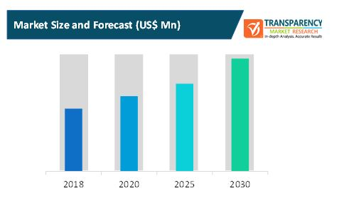

### **Global Online Coding for Kids Market, by Coding Level Level**

* Pre Level Coding – Grade KG to 2 | Age 6-7
* Elementary Level Coding – Grade 3 to 5 | Age 8-10
* Middle-Level Coding – Grade 6 to 8 | Age 11-13
* High-Level Coding – Grade 9 to 12 | Age 14-18

### **Global Online Coding for Kids Market, by Language Type**

* HTML
* Python
* CSS
* Ruby

## Secondary Research

In the MENA region, Facebook, the world's largest social media network, has 187 million monthly active members. With 38 million daily users and 40 million monthly users, Egypt was the largest Facebook market in the Middle East and North Africa (MENA).

**The Middle East loves social media and that’s not an exaggeration:**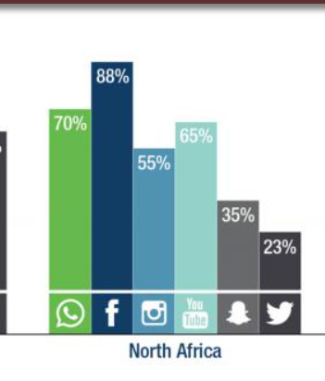

for example, Facebook is gaining popularity across North Africa, particularly in Egypt, Morocco, and Algeria. As of October 2020, Egypt is the world's ninth largest Facebook market, with 44 million users. Turkey is the only other MENA country in the Top 20, ranked 13th — ahead of Columbia and behind the UK, with 37 million users.

### **Social media in the MENA region last year:**

* According to research from GlobalWebIndex (GWI), Internet users in the Middle East have an average of 8.4 social media profiles.
* According to Forbes, the UAE has “the largest number of social media accounts per person globally,” with an average of 10.5 accounts.
* Egypt is the 9th largest national market for Facebook in the world, with 44 million users, as of [October 2020](https://hootsuite.com/resources/digital2020-q4-update).Libya (100%), UAE (93%) and Qatar (90%) are among the countries with the highest levels of reach for Facebook, relative to the population, according to [data](https://hootsuite.com/resources/digital2020-q4-update) from We Are Social and Hootsuite.
* Egypt, Morocco and Algeria are ranked in the Top 10 territories for the fastest growing number of Facebook users, demonstrating how Facebook is continuing to grow in several North African markets.

**Egypt**: Egypt is still considered the most active nation on Facebook; the number of users has increased from 38M to 44M since 2020.

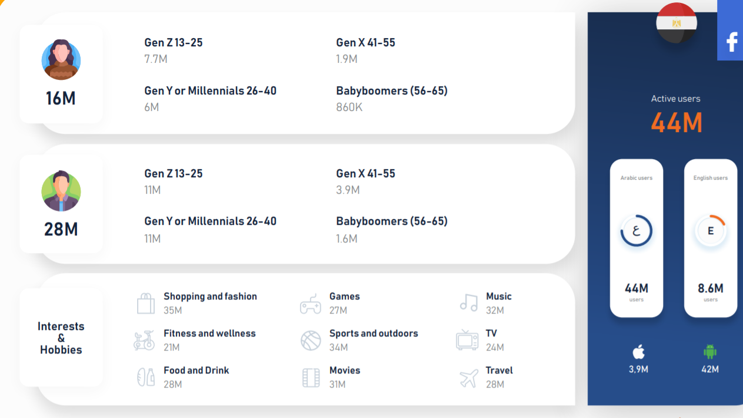

**Saudi Arabia:** Saudi Arabia had the highest user base on Twitter. Arabic is the main language used on most platforms except Facebook, which is one of the least popular platforms in Saudi Arabia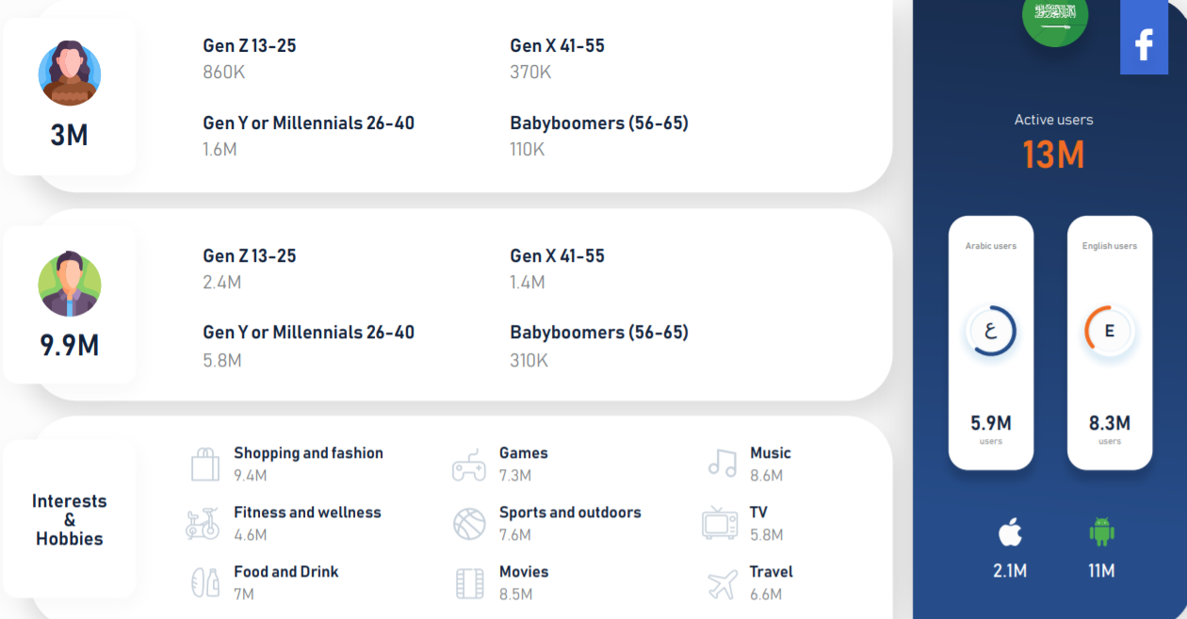

**United Arab Emirates:** The most popular platform in the UAE is Facebook with the highest number of female users compared to male users, while the least popular is Twitter.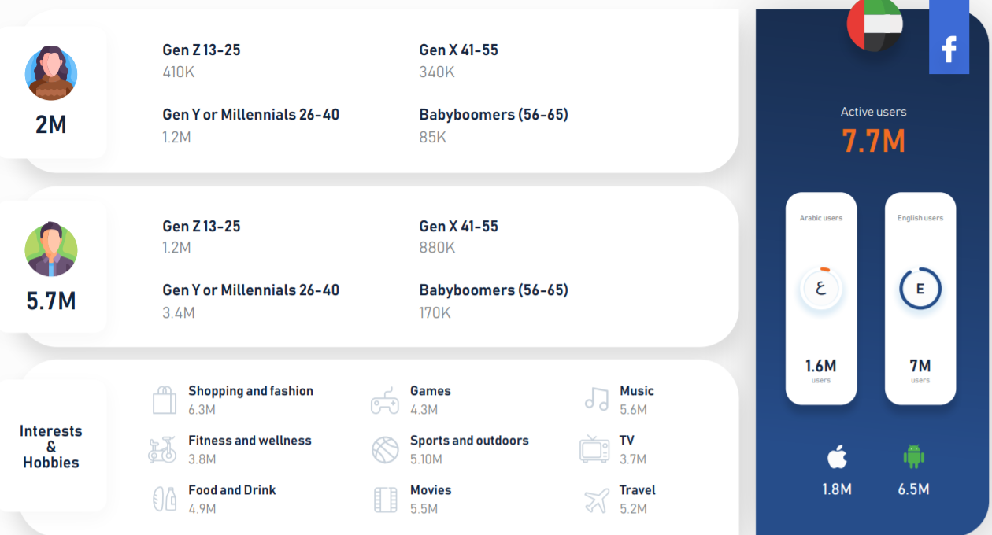

## Macro & micro environmental data about the region

### **Economics factors**

Investment U.S. foreign direct investment (FDI) in MENA countries (stock) was $42.1 billion in 2007, up 14.7 percent from 2006

### **Key MENA Economies**

* Kingdom of Saudi Arabia: By far the largest economy in the MENA region, the Kingdom of Saudi Arabia reported a Gross Domestic Product of $792.97 billion in 2019, according to [Statista](https://www.statista.com/statistics/804761/gdp-of-the-mena-countries/).
* Islamic Republic of Iran: Iran is the second-largest economy in the MENA region, despite a strict sanctions regime that makes it difficult for exporters to earn foreign currency
* State of Israel: With a GDP of $395 billion in 2019, Israel is the [fourth-largest](https://www.statista.com/statistics/804761/gdp-of-the-mena-countries/) economy in the MENA region. makes it difficult for exporters to earn foreign currency.
* Egypt: With a 2019 GDP of $302 billion, Egypt represents the largest economy in North Africa, but only the fifth-largest in the MENA region as a whole.

### **Income Levels**

Income levels show wide variations within the region. Per capita GDP in 2002 ranged from an estimated high of US$37,600 for Qatar to US$930 for Yemen, both measured using purchasing power parity (PPP) exchange rates that allow for cross-country differences in price levels. The six oil-rich countries of the Gulf Cooperation Council (GCC) have the highest per capita GDP in the region.

### **Demographic forces**

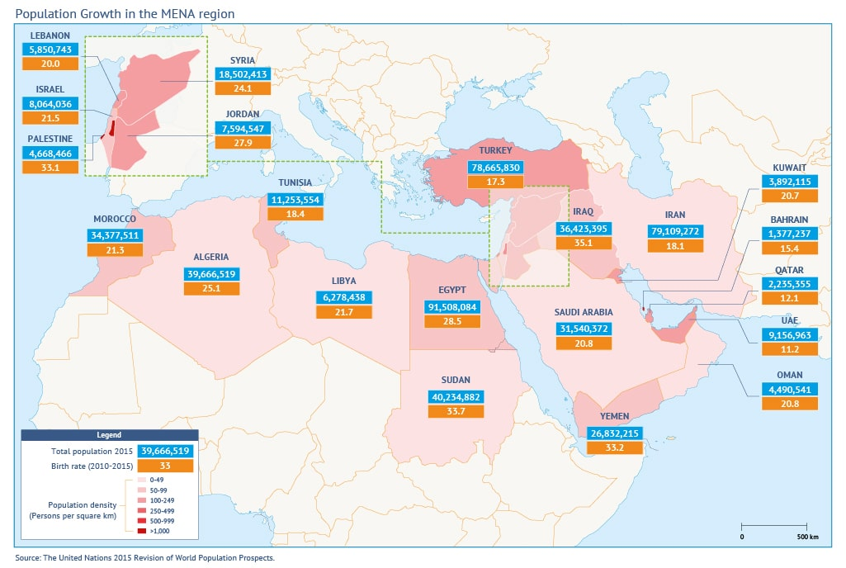

1. Population size and growth

In 2010, the world population reached 6.9 billion, with 5.7 billion or 82 percent living in developing countries. Of these, 359 million reside in the 22 countries and areas of the Arab Region and together account for five per cent of world population . One in 20 people in the world live in the 22 countries of the Arab Region.The population of the Arab countries nearly tripled between 1970 and 2010, climbing from 128 million to 359 million. According to the medium variant projection, the Arab Region will have 598 million inhabitants by 2050, increasing by two-thirds or 239 million more people than in 2010 Arab Region represented 4 percent of world population in 1970, this increased to 5 per cent in 2010. By 2050,The largest population increments between 2010 and 2050 are expected to take place in Egypt (45million), Iraq and Sudan (33 million each) and Yemen (29 million).Most of the Region’s population is concentrated in a few countries. Today, about half of the Region’s population resides in Algeria, Egypt and Sudan. With a projected population of 130 million by 2050, Egypt is expected to be the 12th most-populated country in the world by mid-century.

1. Age structure

Currently, the population of the Arab Region is still young, with children under age 15 accounting for a third of the population and young persons aged 15 to 24 years accounting for a fifth. Thus, in the Arab Region, a majority of the population, 54 per cent, is now under the age of 25 .The number of children and youth is at an all time high in the Region; there are 121 million children and 71 million young people, for a total of 192 million. The increase in the proportion of 15 to 24 year olds in the total population, referred to as the “youth bulge,” combined with the rapid growth in the overall population, has resulted in the most rapid growth in the number of young people in the Region’s modern history. The number of children and youth is expected to climb to 217 million by 2050.

### **Technological factors**

Broadband is affordable to the average MENA consumer. But long-term sustainability and satisfactory use of internet services are not affordable to low-income groups. A smartphone unit costs nearly 20% of monthly income, but represents 96% of the average income of the poorest 20%.

MBB download speed varies between 74 Mbps (UAE) and 7 Mbps (Tunisia), and bandwidth ranges between 300 kbits (UAE) and 16 kbits (Egypt).

FBB download speed varies between 84 Mbps (UAE) and 10 Mbps (Egypt). But the majority are covered by much lower speed: 75% in UAE and Saudi Arabia are within the footprint of 15 Mbps network; and 65% in Egypt are covered by networks ranging in speed between 256 kbits and 2 Mbits

In summary, MENA-HIC affordability, usage and quality matched, and in some instances surpassed, levels recorded in advanced economies. In contrast, MENA-MIC, are trailing behind in all indicators, across all income levels and especially in rural areas.

The Covid-19 pandemic and the ensuing lockdown affirmed high-speed internet as a fundamental need and laid down the foundation for managing the internet as a public good.

For example, between 2014 and 2016, the percentage of youth/adults who downloaded or configured software in Egypt surged by 4,000%. Using spreadsheets in arithmetic calculations jumped by 620%, and writing computer programs grew by 164%. (UNISCO-UIS-Database). During the same period, internet users grew from 34% to 41%; MBB subscribers expanded from 28% to 44%; and FBB subscribers only increased from 2% to 4%.

Main digital connectivity challenges faced by the region

Despite government solutions and initiatives, there are several bottlenecks that the sector witnessed during the pandemic and several risks that need to be addressed. These include

* Inability of several telecom operators to continue their business for operations, requiring physical presence of their employees at work sites as they needed to respond to lock down requirements.
* Increasing cyberattacks, fake news and incidents of digital fraud that exploit the public panic and uncertainty surrounding the COVID-19.
* Privacy and personal data protection concerns for the use of CDR and mobility data for contact tracing and tracking to flatten the curve and prevent the spread of the virus.

Governments of MENA countries should reinforce their efforts to achieve the following objectives based on the COVID-19 early lessons:

* Increasing capacities and reducing network congestion to prevent disconnection and ensure sustainability
* Ensuring continuity of public services to enable citizens to make use of digital technology to complete their transactions
* Promoting e-learning initiatives to ensure education continuity.

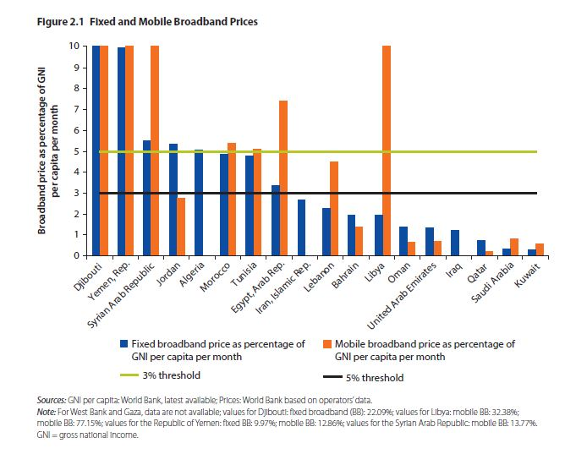

Internet usage frequency 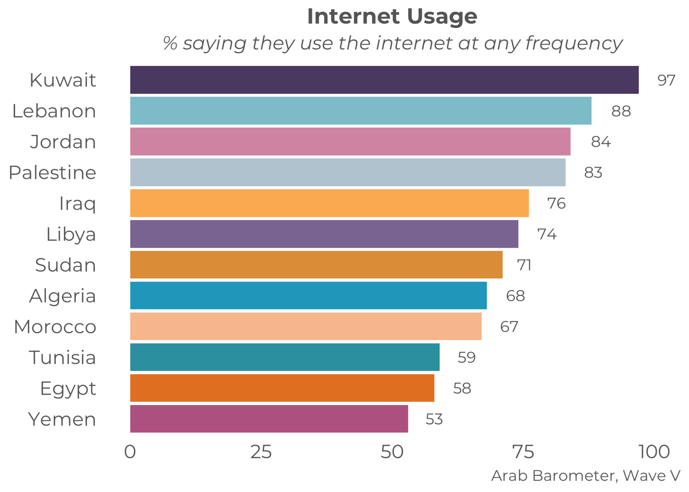

### **Social and cultural forces**

* Percentage-of-universities-using-e-learning-in-each-country

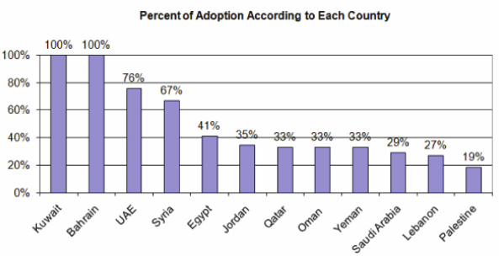

* Percentage-of-governmental-versus-private-adoption-for-e-learning-in-each-country

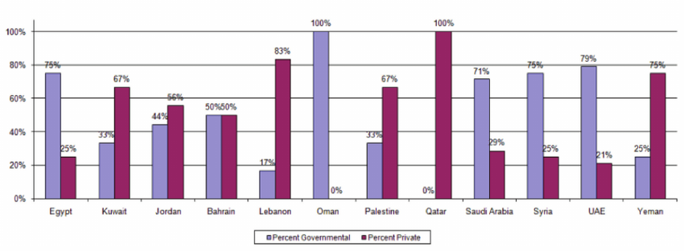

### **Political and legal forces**

The Middle East has long been one of the most unstable regions in the world, and there are no present prospects for change in the near future. This instability is the result of ongoing conflicts and tensions, and a variety of political tensions and divisions. It also, however, is the result of a wide variety of long-term pressures growing out of poor governance, corruption, economic failures, demographic pressures, and other forces within the civil sector.

**The Short and Long-Term Forces Shaping Stability and Instability**

The immediate sources of instability are clear. Most of the region has some form of internal conflict, faces rising external threats, or is dealing with violent extremism. The violence and wars that have resulted from the political upheavals in 2011 will at best leave lasting challenges for unity and development even if the fighting ends. All the major causes of violent extremism remain, and there are few prospects that the fight against ISIS will eliminate the extremist threat in even one MENA country. Tensions between Israel and the Palestinian persist, each side has seen rising internal political barriers to a compromise peace, and the tensions between Israel and Iran and Hezbollah are creating new military threats.

The longer-term pressures are less clear, although a wide range of international organizations like the UN, World Bank, and IMF have warned about the individual forces involved for decades. Arab experts have documented the level of such pressures in the UN's Arab Development Reports since 2002, and many of the forces involved have consistent trends lines and can be quantified by country. These reports reveal radical differences between the countries in the region, but highlight the fact that given countries have mix of poor and abusive governance, ethnic and sectarian differences, corruption and self-seeking elites, poor or failed economic development, employment and career problems, and population pressures that challenge national unity and stability, and help lead to violent extremism.

### **General Factors**

The **key challenges** governments and universities in the MENA region are facing with regard to moving courses online are the following:

• Lack of access to internet/WIFI and lack of sufficient bandwidth in many student households

• Lack of hardware such as tablets and laptops for student use at home

• Limited availability of online course content/limited possibility of moving courses online (for example, due to the nature of the subject, such as lab work in medicine or chemistry) 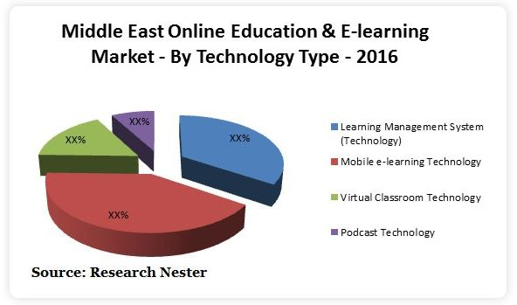

### 

### **The market size and market growth rate.**

Market Size and Forecast

Regionally, the Middle-East Online Education/e-learning Market is segmented into UAE, Saudi Arabia, Qatar, Oman and Bahrain. Among these, UAE is anticipated to witness a significant growth and occupy the largest share of the online education/e-learning market by 2023.

Middle-East Online education/e-learning market is expected to register a CAGR of 17.4% over the forecast period 2016-2023 due to introduction of strong education mandate and [increase in education budget](https://www.researchnester.com/reports/middle-east-online-educatione-learning-market-global-demand-growth-analysis-opportunity-outlook-2023/238) to digitize the education for the betterment of students.

Smartphone & Tablet users: Rising penetration

Availability of high-end smartphones and tablets with user friendly interface in the market at affordable cost is expected to raise the smart phone users across the region over the forecast period 2016-2023 which will further expected to fuel the growth of online education/e-learning market.

Distribution of tablets and laptops to the students in schools and colleges to promote e-learning by the government authorities to enhance the higher education is expected to spur the demand for online education/e-learning during the forecast period 2016-2023.

Low cost data and launch of new educational e-learning apps is anticipated to grow the market of online education/e-learning across the region of Middle-East.

Enhanced Simulation Technology: Turning Phase

The advancement of technology in simulation and graphics used to provide simulated training and e-learning programs to enhance learning. This advanced technology of graphics and animations make learning easy for the population of corporate as well as education sector which will further expected to fuel the growth for online education/e-learning market across the region of Middle-East.

Rising awareness towards distance learning education and distance web based learning is expected to increase the users of online education/e-learning due to upcoming and present advanced technology which provides learning without any interruptions related to low networks. This will further expect to enforce the demand for online education/e-learning across the Middle-East countries.

## Competitive analysis of the top similar initiatives

|  | **Barmej** | **Harmash** | **Code.org** | **almentor.net** |
| --- | --- | --- | --- | --- |
| **Language** | Arabic | Arabic | English - Arabic | Arabic |
| **Product Summary** | An Arabic online learning platform that offers courses in different programming languages. Courses are aimed at Arabic speakers who have no technical experience in coding language | An arabic platform that offers different programing languages courses for users who want to be professional programmers | a nonprofit dedicated to expanding access to computer science in schools and increasing participation by young women and students from other underrepresented groups. | UAE-based almentor.net is offering video courses in Arabic and English. Its mission is to address the lack of online personal development content for Arabic-speakers. |
| **Price Range** | Paid | Paid | Free | Paid |
| **Target Age Group** | All ages | All ages | 4 - 18 age | All ages |
| **No of Users (students)** | 287k | - | 4 million | 551K |
| **Competitor Category** | Direct | Direct | Direct | Secondary |
| **Subscription fee** | Average 92$ | Average 160 $ | - | Average 50 $ |
| **Free Trial Availability** | Yes | Yes | Yes | No |
| **Marketing Channel** | Facebook,  Twitter,Instagram and github | Facebook,  Twitter, Youtube and Telegram | Facebook,  Instagram, Twitter and Medium | Facebook,  Instagram, Twitter ,Youtube and Linkedin |

## Similar software for product inspiration

| **1** | **Codecademy** courses cover how to build a website and a whole slew of related coding languages, including HTML & CSS, Ruby on Rails, Python, JavaScript, jQuery, SQL, PHP, and more. |
| --- | --- |
| **3** | **Codingal** is a community-driven mobile and web-based platform for kids to learn to code together. It has a unique curriculum: it's the world's only coding curriculum based on BIDE, STEAM, and Bloom's Taxonomy designed to teach coding scientifically.  The platform incorporates the standard and industry vetted K-12 computer science framework to create guided products, videos, and live tutoring sessions to teach coding and logical thinking to students. |
| **4** | **Scratch** is the platform that enables elementary school coding programs. It’s a free block coding website for kids, developed by the MIT Media Lab. Scratch is its native programming language and consists of graphical blocks that snap together  The platform is designed especially for kids ages 8 to 16. Younger children can also try ScratchJr, a simplified version of Scratch intended for ages 5 to 7. |
| **5** | **Khan Academy** offers expert-created content and resources for free online courses and practice. Khan Academy teaches the patterns of programming. It’s a great start to get a handle on how computer programming works in general before you dive into specific languages.  For computer programming, Khan Academy has courses in JavaScript, Processing JS, HTML & CSS, HTML & JavaScript and SQL. Each of these courses presents a comprehensive introduction aimed at building a base for professional-level skills. |

## SWOT Analysis

| **Strength**   * Marketing Channel owner * The high number of Facebook users in the MENA region * Easily accessed through online active user * Strong platform * Strong advertising | **Weakness**   * Offline access to course * Not having an account will prevent kids from accessing the feature * Facebook is not considered a learning company * Good Internet coverage and speed |
| --- | --- |
| **Opportunities**   * Diversity portfolio of the MENA region * Expanding existing platform * Increasing integration to other application * Online learning expansion after Covid-19 * Rising awareness towards distance learning * Governments in the region working on enhancing factors such as internet access and hardware for students as a result for Covid-19 | **Threats**   * Kids find that the feature is not interesting (Content /Instructor) * No Demand for learning programming for kids * Instructors proficiency for teaching kids * Other online platforms accessible in MENA/Strong competition * Lack of access to internet/WIFI and insufficient bandwidth in many users households * Lack of hardware( tablets and laptops) for student use at home |

## Conclusion and recommendations

Online coding courses for kids are a great way to increase the skills and learning power of kids. In light of the initiatives that are mentioned in the research <https://blogs.worldbank.org/arabvoices/bringing-arabicized-computer-science-education-mena-region> There is a huge need for Arabic programming courses in the MENA region. The decision would be for Facebook to enter the sector and make a significant influence as the market's exponential expansion provides limitless chances. People in the MENA region spend a lot of time on social media, averaging about 3.5 hours a day, across platforms. Based on the below factors:

* Egypt is the largest market for Facebook in MENA with 38 million daily users and 40 million monthly users.
* Egypt is the ninth-largest market for Facebook in the world, with 44 million users, as of October 2020.
* Egypt is covered by networks ranging in speed between 256 kbits and 2 Mbits
* Most of the learning platforms users are from Egypt
* Social media usage continues to grow at a very quick pace in Egypt
* Egypt represents the largest economy in North Africa.

We recommend starting the initiative in Egypt, and due to the large market and high growth rate, We believe that implementing this initiative in Egypt will have the greatest impact among other regions.

## **References**

1. <https://www.ilo.org/wcmsp5/groups/public/---dgreports/---dcomm/---publ/documents/publication/wcms_650553.pdf>
2. <https://ustr.gov/countries-regions/europe-middle-east/middle-east/north-africa>
3. <https://www.investopedia.com/terms/m/middle-east-and-north-africa-mena.asp>
4. <https://www.iai.it/sites/default/files/menara_wp_21.pdf>
5. <https://www.imf.org/external/pubs/ft/med/2003/eng/abed.htm>
6. <https://www.worldbank.org/en/region/mena/publication/broadband-networks-in-mna>
7. <https://blogs.worldbank.org/arabvoices/digital-transformation-time-covid-19-case-mena>
8. <https://www.arabbarometer.org/2020/09/the-mena-digital-divide/>
9. <https://fanack.com/egypt/population-of-egypt/egypt-growing-population/>
10. <https://www.researchnester.com/reports/middle-east-online-education-e-learning-market-demand-growth-analysis-opportunity-outlook-2023/337>
11. <https://www.marketwatch.com/press-release/middle-east-online-educatione-learning-market-size-share-analysis-growth-insights-and-forecast-to-2023-2021-06-22>
12. <https://theforum.erf.org.eg/2020/12/15/broadband-mena-ready/>
13. <https://sciexaminer.com/news/online-coding-for-kids-market-research-analysis-including-growth-factors-types-and-application-by-regions-by-2030-156320.html>
14. <https://dzone.com/articles/coding-platforms-for-kids>
15. <https://www.arabnet.me/english/editorials/business/industry/kalimat-first-arabic-programming-language-for-kids>
16. <https://harmash.com/home/>
17. <https://menafn.com/1101129131/Jordan-Edraak-Codeorg-create-online-coding-program-for-children-across-MENA>
18. <https://studio.code.org/courses>
19. <https://thearabweekly.com/social-media-use-youth-rising-across-middle-east>
20. <https://wan-ifra.org/2021/06/tiktok-trumps-snapchat-social-media-trends-in-mena-in-2020/>
21. <https://www.csis.org/analysis/stability-middle-east-range-short-and-long-term-causes>
22. <https://www.linkedin.com/pulse/how-middle-east-uses-social-media-20-standout-stats-from-radcliffe/>